CMSC 447

Software User Manual (SUM)

1. Scope
   1. Identification

This paragraph shall contain a full identification of the system and the software to which this document applies, including, as applicable, identification number(s), title(s), abbreviation(s), version number(s), and release number(s). (*)

* 1. System overview

This webpage aims to provide information about areas to move to within the United States consistent with specified criteria. Each specified criteria will appear as a search option on a webpage and will be used by a user to narrow down results for a new location to move to. Locations fitting the criteria of the search will be displayed on a map as points.

* 1. Document overview

This document outlines procedures for operating our software. Features are described at the component level.

1. Referenced documents

[If you reference documents in the future, include them here]

1. Software summary

The purpose of our software is to determine which areas of the country “match up” with the user’s preferences. These user inputs their preferences by activating the components described below. Areas that match are marked by pins and given descriptions of how closely they match the initial criteria.

* 1. Software application

Our software is targeted at users who, for whatever reason, are interested in determining which areas of the country align with their living/housing preferences.

* 1. Software inventory

It is not necessary to install any files to use our software. One needs only to open the webpage in their browser (of course, a web browser is necessary).

* 1. Software environment

The following is an itemization of the resources necessary for software operation:

* A relatively up to date web browser [replace this with browser versions]. Candidate web browsers include Chrome, Firefox, and Safari.
* Internet access

[Include other resources necessary for operation here (this might be it)]

* 1. Software organization and overview of operation

The following is a sequence of steps that defines software operation from the user’s point of view:

1. First, open the search criteria menu. This is done by clicking the hamburger icon in the top left corner of the web page.
2. Next, activate the search components that are important to you. If there is a drop down menu for that component, select the condition that most aligns with your preferences.
3. Then, when you have finished inputting your preferences, press the search button and wait for the results to be returned. Note: This may take up to 10 seconds depending on the query.
4. Finally, if you are interested in *why* a particular area was given a pin, click on that pin to see how closely that area matches your initial criteria.
   1. Assistance and problem reporting

To obtain assistance or report problems contact a development team member:

* Dan [insert e-mail here]
* Kyle [insert e-mail here]
* Rushmie [insert e-mail here]
* Jon [insert e-mail here]
* Tyler [insert e-mail here]
* Doug [insert e-mail here]
* Brian [insert e-mail here]

1. Access to the software

Accessing the software only requires one step. One needs only to enter the site url [insert final site url here] into their browser’s address bar.

* 1. First-time user of the software

### Installation and setup

No installation is required for using our software (apart from the installation of a web browser). For more information on how to access the site, refer to section 4.

1. Processing reference guide
   1. Capabilities

The following is an itemization of all software components and descriptions of how they are to be used:

* The search criteria menu contains the components that let the user input their preferences. To open the menu, click the hamburger icon in the top left corner of the screen. To close the menu, click the X in the top right corner.

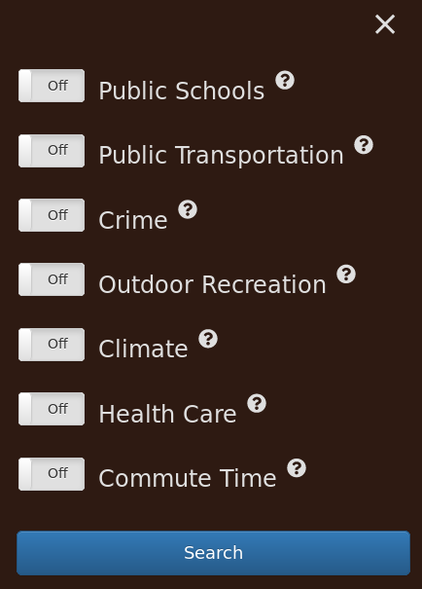

* The public schools, public transportation, and crime components all work the same way. To activate these components, make sure the on/off button is on the on positon. Then, select the condition from the drop down menu that most aligns with your preferences.

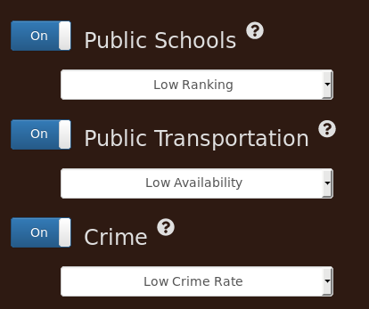

* The outdoor recreation component works in roughly the same way as the other components, but instead of a dropdown menu it uses buttons to set conditions. When using this component, turn on all of the subcomponents that correspond to recreational activities you are interested in.

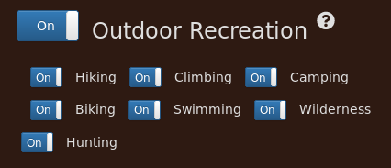

* Again, the climate component works in roughly the same way as the others. The difference here is that you must select conditions from three dropdown menus instead of one.

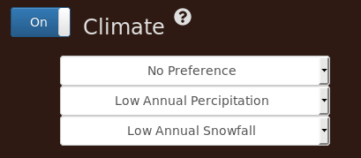

* The healthcare component works the same way as the first three. To use this component, set the on/off button to the on position and select a condition from the drop down menu.

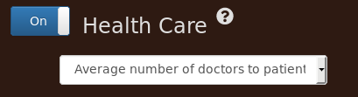

* To use the commute time component, set the on/off button to the on position and slide the slider to an average commute time that you consider acceptable.



* Each component has a help button in the upper right hand corner. These help buttons contain information about how to use each component.



* The active criteria bar displays all search criteria that are set to the on position. It is located at the top of the webpage above the map display.



* The map display is located at the center of the webpage and is where the results will be displayed.

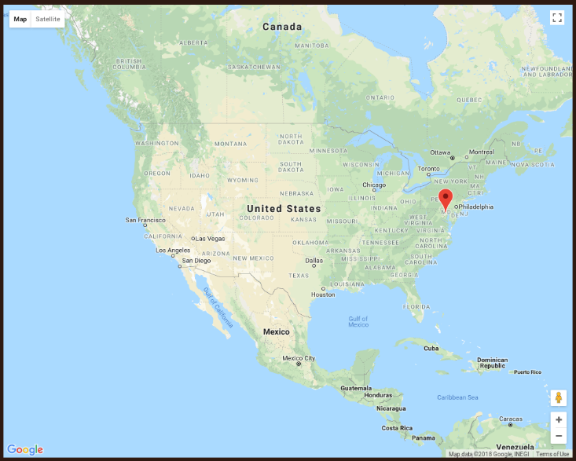

* Each result will be represented as a pin on the map display. Clicking on a pin will display additional information about how closely that result matches the initial search criteria.



* 1. Recovery from errors, malfunctions, and emergencies

[Insert any future error handling information here]

* 1. Messages

[Add help messages here]

* 1. Quick-reference guide

[Leaving this section for future use]

1. Notes

[Leaving this section for future use]

DESCRIPTION/PURPOSE

The Software User Manual (SUM) tells a hands-on software user how to install and use a Computer Software Configuration Item (CSCI), a group of related CSCIs, or a software system or subsystem. It may also cover a particular aspect of software operation, such as instructions for a particular position or task.

The SUM is developed for software that is run by the user and has a user interface requiring on-line user input or interpretation of displayed output. If the software is embedded in a hardware-software system, user manuals or operating procedures for that system may make separate SUMs unnecessary.

APPLICATION/INTERRELATIONSHIP

Portions of this plan may be bound separately if this approach enhances their usability. Examples include plans for software configuration management and software quality assurance.

The Contract Data Requirements List (CDRL) should specify whether deliverable data are to be delivered on paper or electronic media; are to be in a given electronic form (such as ASCII, CALS, or compatible with a specified word processor or other support software); may be delivered in developer format rather than in the format specified herein; and may reside in a computer-aided software engineering (CASE) or other automated tool rather than in the form of a traditional document.

PREPARATION INSTRUCTIONS

General instructions.

a. Automated techniques. Use of automated techniques is encouraged. The term "document" in this means a collection of data regardless of its medium.

b. Alternate presentation styles. Diagrams, tables, matrices, and other presentation styles are acceptable substitutes for text when data required can be made more readable using these styles.

c. Title page or identifier. The document shall include a title page containing, as applicable: document number; volume number; version/revision indicator; security markings or other restrictions on the handling of the document; date; document title; name, abbreviation, and any other identifier for the system, subsystem, or item to which the document applies; contract number; CDRL item number; organization for which the document has been prepared; name and address of the preparing organization; and distribution statement. For data in a database or other alternative form, this information shall be included on external and internal labels or by equivalent identification methods.

d. Table of contents. The document shall contain a table of contents providing the number, title, and page number of each titled paragraph, figure, table, and appendix. For data in a database or other alternative form, this information shall consist of an internal or external table of contents containing pointers to, or instructions for accessing, each paragraph, figure, table, and appendix or their equivalents.

e. Page numbering/labeling. Each page shall contain a unique page number and display the document number, including version, volume, and date, as applicable. For data in a database or other alternative form, files, screens, or other entities shall be assigned names or numbers in such a way that desired data can be indexed and accessed.

f. Response to tailoring instructions. If a paragraph is tailored out of this document, the resulting document shall contain the corresponding paragraph number and title, followed by "This paragraph has been tailored out." For data in a database or other alternative form, this representation need occur only in the table of contents or equivalent.

g. Multiple paragraphs and subparagraphs. Any section, paragraph, or subparagraph in this DID may be written as multiple paragraphs or subparagraphs to enhance readability.

h. Standard data descriptions. If a data description required by this document has been published in a standard data element dictionary specified in the contract, reference to an entry in that dictionary is preferred over including the description itself.

i. Substitution of existing documents. Commercial or other existing documents, including other project plans, may be substituted for all or part of the document if they contain the required data.